APOLLO Bio-sample Labeling:
● Choose correct label template to open (saved on computer) …. Either Recipient or Living Donor
Recipient ↓ Donor ↓
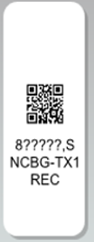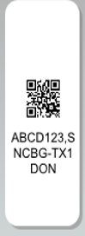
● Make sure your assigned transplant center code is correct or fix it in text and in QR code (both places)
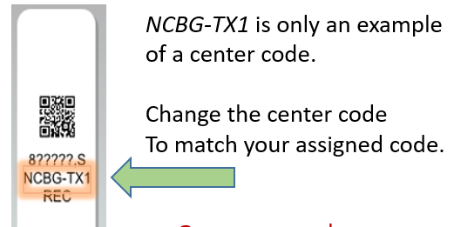
* Don’t forget to change code in QR box as well (double click on black and white box to change).
● Enter Participant ID … in text and in QR code
For Recipient – Enter TRR#
For Living Donor – enter UNOS ID #

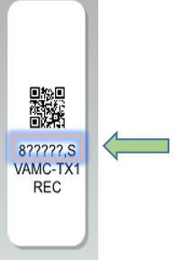

●Enter sample type…in text and in QR code
S=serum (print 12)
U=urine (print 12)
D=DNA (print 1)
X= biopsy tissue- (print 1 -for ancillary study only)
Do not change text size for format, do not remove any commas.

Print one label to review for accuracy, QR code can be scanned with phone to determine accuracy.
If correct, continue printing remaining needed labels.

●Affix to samples, do not cut labels.
