APOLLO 1/17/2019
MOP Chapter “OPOs and HLA Labs: Enrollment and collection for deceased donors” Abbreviations

AA African American
ACD acid citrate dextrose
AOPO Association of Organ Procurement Organizations
APOL1 apolipoprotein L1 gene
APOLLO APOL1 Long-term Kidney Transplantation Outcomes Network
DNA deoxyribonucleic acid
NIH National Institutes of Health
HLA human leukocyte antigen
IRB institutional review board
MOP manual of procedures
NOK next of kin
OPO organ procurement organization
SC Steering Committee
SDRC Scientific and Data Research Center (also called Coordinating Center)
UNOS United Network for Organ Sharing
WFSM Wake Forest School of Medicine
APOLLO 1/17/2019
MOP Chapter “OPOs and HLA Labs: Enrollment and collection for deceased donors”

1. Overview

Collection of DNA from deceased African American (AA) kidney donors is the most critical aspect of the APOLLO study. OPOs and HLA Labs are collaborating with the APOLLO study to collect, process, and ship biosamples from deceased donors who are AA or have African ancestry. The procedure for enrollment and processing is intended to be as non-disruptive as possible for the OPOs and HLA Labs. Though deceased donors are not considered research participants by the National Institutes of Health Office for Human Research Protections for this study, all OPOs and HLA Labs will have the opportunity to review and approve the proposed APOLLO activity. The study and these procedures have been reviewed and approved by the IRB responsible for oversight of the Scientific Data Research Center (SDRC).

Established protocols for authorizing organ donation and research from donor families should not be affected by the APOLLO protocol. Deceased donors are eligible for APOLLO if they are AA or have African ancestry and, there is authorization for research; the donor or their family representative agrees that the donor’s biosamples may be included in research studies. Each OPO is being asked to determine eligibility, collect 2 additional tubes of blood and 1 tube of urine and ship them to its HLA lab along with other routinely collected samples which are sent to that lab. Following their existing local procedures, HLA Labs will extract DNA, separate serum, and store the frozen DNA, serum and urine. The HLA Labs will ship APOLLO samples in batches to the APOLLO Central Lab. A video with detailed specimen handling and shipping instructions for HLA Labs is available on the APOLLO website (www.TheApolloNetwork.org). Near the end of the study, when all genotyping for enrolled deceased donors is complete, each OPO will send a letter to the deceased organ donors’ Next of Kin (NOK) offering them access to the genotyping results through the APOLLO website.

2. Procedures for Organ Procurement Organizations

2.1 Who is Eligible for Inclusion in APOLLO, and Who Determines Eligibility?
To be eligible, a deceased donor must be reported as AA by the OPO, based on having “African ancestry” which for this study is defined as AA, Afro-Caribbean, Hispanic Black, or African from whom kidneys will be recovered for transplantation. The OPO can determine this by using the Deceased Donor Registration Worksheet or whatever other sources are used to complete the Ethnicity/Race question on the Deceased Donor Registration Worksheet. It can also be determined by reports from family members or by hospital records. In addition, there must be authorization for research by the donor or NOK to be included in the APOLLO project. Authorization for research will be facilitated by each OPO following their normal procedures. There are no exclusions for age, gender, causes of death or other reasons.

2.2 Instructions for Blood and Urine collection, Labelling and Shipping to the HLA Lab:
APOLLO will provide each OPO with labels with the words ‘APOLLO sample’ and 10 mL urine tubes (Fisher Scientific Cat. # NC9054766).

During routine sample collection, each OPO will collect an additional 2 tubes of whole blood and 1 tube of urine for each eligible deceased donor as follows:
For whole blood:
an 8.5 mL ACD tube (yellow top tube, provided by the OPO) and
a 10 mL serum tube (red top tube, provided by the OPO).
For urine:
a 10 mL urine tube (provided by APOLLO, and capable of cryopreservation).

Collection tubes can be labeled in advance if it is convenient to do so. All three APOLLO tubes will be labeled the same way that other specimen tubes are typically labeled for shipment to the HLA Lab; however, each APOLLO tube should also have an “APOLLO sample” label. The “APOLLO sample” labeling will alert the HLA lab that these are extra APOLLO study specimens. At a minimum, labels on the APOLLO tubes should include the UNOS ID number and if possible the date and time of collection.

The OPO will ship the APOLLO samples with other samples already going to the HLA Lab using their standard procedures (APOLLO samples follow the clinical samples). In addition, a one-page APOLLO HLA Lab Instruction Sheet (Appendix 1) should be included. The HLA lab instruction sheet is intended to help ensure the HLA Lab is aware that they should process, store and ship the APOLLO tubes as described in the instruction sheet.

The OPO will send an email to the APOLLO SDRC (APOLLOLab@wakehealth.edu) indicating that samples were collected and sent to their corresponding HLA Lab, and also notify the OPO’s Donor Family Services team so the OPO will have that information for donor family follow-up letters. The email must include the UNOS number. The OPO may also choose to “cc” their HLA lab on this email.

If an additional ACD (yellow top tube) is not able to be collected, but there is authorization for research, the OPO should notify their HLA lab to secure any excess DNA material, after normal procedures and requirements for transplantation, and collect and store as otherwise described.

2.3 The APOLLO Study Notification Sheet to be Included with Recovered Kidneys:
Organ recovery procedures for APOLLO identified kidneys should follow standard practice for the OPO. If one or more kidneys are recovered and sent to a transplant program, OPOs will include the APOLLO Study Notification Sheet (Appendix 2) in the shipping container with each kidney. This sheet is intended to alert the transplant program to facilitate recruitment of the kidney transplant recipient into the APOLLO project.

3. HLA Labs

3.1 APOLLO will Provide to HLA Labs:
- 2 mL cryovials for DNA (sterile, freezer-safe; Fisher Scientific Cat # 03 337 7D). Alternatively, HLA labs can elect to use their own 2 mL freezer-safe cryovials
- 5 mL cryovials for serum (sterile, freezer-safe; Sarstedt Cat # 62.558.201)
- 5-inch 7x7 Cardboard Storage Boxes (Globe Scientific, Cat # 3098)

  - Receipt and Processing of APOLLO Samples:
  - The OPO will provide an additional 8.5 mL ACD-A (yellow top) tube, an additional 10 mL clot (red top) tube and a 10 mL tube with urine for every eligible deceased donor with African ancestry that has a kidney recovered for transplantation. These should be distinguished by additional labeling with the word “APOLLO” Study on each tube.

  - The most critical task is to collect DNA to ship to the APOLLO SDRC. The HLA Lab will obtain as much DNA as possible from each extra ACD-A tube (20 μg of DNA recovered would be excellent). This can be isolated using the HLA Lab’s standard DNA isolation protocol. The recovered DNA should be transferred to the 2.0 mL cryovial provided by APOLLO (or the HLA Lab’s own 2mL cryovial suitable for storage at -80°C).

  - In the unlikely event an additional ACD tube for the APOLLO project is not able to be recovered, the OPO may request that the HLA Lab, after securing the DNA needed for standard donor tissue typing purposes, will secure any residual DNA (provide at least 250 ng of DNA) for the APOLLO study in the 2.0 mL cryovial provided by APOLLO or their own 2.0 mL cryovial suitable for storage at -80°C.

  - The HLA lab should centrifuge the red top tube and isolate the 3-4.5 mL of serum into the 5ml cryovials provided by APOLLO.

  - The HLA Lab will label the tubes and cryovial as standard practice, including donor UNOS number and date of DNA isolation. If the laboratory is able to include the DNA concentration and 260/280 ratio with each DNA cryovial, that would be appreciated. The urine tube, serum tube, and DNA cryovial, grouped by UNOS ID, will be placed into a reusable 5-inch 7x7 cardboard box with the vials upright in the box for storage in an ultra-low temp freezer. The 5-inch 7x7 boxes will be re-used for sample storage by the HLA Labs (these boxes will not be shipped to APOLLO). A video with detailed specimen handling instructions is available on the APOLLO website (www.TheApolloNetwork.org). Processing and storage of samples should take place at the same time other samples for the donor are processed, or as soon as possible, to maintain the integrity of the samples.

  - Sample Storage and Shipping:

- The HLA Lab will ensure that DNA and serum samples are each securely placed in a tube sufficient (volume, size and material) to allow for storage in an ultra-low temp freezer at -80°C. These tubes will be stored with the tube of urine from that donor in the ultra-low freezer. Samples will be shipped via FedEx on dry ice to the APOLLO SDRC Central Lab (see below). A video with detailed specimen shipping instructions is available on the APOLLO website (www.TheApolloNetwork.org).

- Due to the large volume of samples to be received from across the country, the shipping process and costs are simplified by batch shipping of samples, preferably every 3 months from each HLA Lab. Thus, while stored in the HLA Lab, samples must be stored in an ultra-low temp freezer (-80°C) until shipped to the APOLLO Central Lab at Wake Forest School of Medicine via FedEx. A representative from the APOLLO SDRC Central Lab will contact each HLA Lab to arrange each shipment. The integrity of these samples is critical and freeze/thaw cycles kept to a minimum.

- Each HLA Lab will be asked to complete and maintain an ongoing APOLLO Sample Inventory Shipping Spreadsheet (Appendix 3) on their local shared computer (to be accessed by different personnel who may be processing samples). The excel log will be completed for each participant after biosamples are collected, aliquoted and stored in freezers. Staff should enter the following information:
- Participant UNOS ID number
- Sample Type U/S/D (urine, serum, DNA)
- Date of preparation
- DNA concentration and 260/280 ratio
- Technician name
- Shipping date (when identified)
- Name of the person shipping the samples

A printed copy of the spreadsheet (with data relevant only to the current shipment) will serve as the “shipping log” to provide detailed sample information for each shipment to the APOLLO Central Lab. The printed lines of the shipping log will be included in the box to be shipped with samples and also e-mailed to the Apollo SDRC Central Lab (ApolloLab@wakehealth.edu). The excel file (APOLLO Inventory and Shipping Spreadsheet) will be maintained for every APOLLO sample collected; however, only the data relevant to the samples in each shipment will be printed and included with the samples. The APOLLO Inventory and Shipping spreadsheet (Appendix 3) is available on the APOLLO website for download by HLA Labs.

- DNA, urine and serum samples must be shipped to the Wake Forest APOLLO Central Lab on dry ice. The costs of shipping, shipping containers and dry ice will be paid by APOLLO. If the HLA Lab is unable to store the samples, more frequent (perhaps immediate) shipping is possible. The APOLLO SDRC Central Lab will work with the HLA Lab to make the necessary arrangements.

- Each HLA Lab should provide a primary contact individual for communication with the APOLLO Central Lab at the Wake Forest School of Medicine.

3.3 Detailed Shipping Instructions:

- Shipments to the APOLLO Central Lab will include:
- The DNA cryovial, serum cryovial, and urine tube from each donor
- Reusable insulated box for shipping (supplied by APOLLO; returned to HLA Lab for subsequent shipments)
- FedEx clear pouch #158396, ordered from FedEx by APOLLO (free from FedEx)
- 9”x6” biohazard bag (Fisherbrand, Catalog No.23-700-211) supplied by APOLLO
- Paper towels (absorbent material) supplied by HLA Labs
- 13”x18” biohazard bag (Fisherbrand, Catalog No. 22-130-111) supplied by APOLLO
- Preprinted FedEx airbill – supplied by APOLLO
- Dry ice label taped to box, ordered from FedEx by APOLLO (free from FedEx) UN3373
- Biological Substance Category B label taped to box (supplied by APOLLO)
- 20 lbs / 9 kg dry ice (covering 2 days) invoice to APOLLO

- To assemble the frozen sample shipments:
- Locate the frozen 2 mL DNA cryovials, the 5mL serum cryovials and 10mL urine tubes (grouped in the freezer by UNOS ID) stored in reusable APOLLO 5-inch 7x7 specimen boxes. Remove the set of 3 samples from each donor case from the specimen box and check to be sure that each tube is properly labeled and the cap is securely tightened.
- Wrap them with a paper towel (as absorbent material). Then place the samples into a 9”x6” biohazard bag and seal the bag. Samples from more than one participant can be placed in each 9”x6” biohazard bag. Multiple 9”x6” bags can be sealed in a larger 13”x18” biohazard bag, and placed into the Styrofoam shipping box/cooler containing dry ice for shipping to the APOLLO SDRC Central Lab.
- First place a layer of dry ice pellets on the bottom of Styrfoam shipping box. Place the larger 13”x18” biohazard bag with the 3 month collection of individual participant specimens on top of a layer of dry ice. Place additional dry ice pellets on top of the bag of specimens. Use at least twenty pounds (9 kg) of dry ice in each shipping box.
- Place the lid on the Styrofoam box. Place the printed APOLLO Inventory and Shipping spreadsheet (Appendix 3, containing only data rows relevant to the current shipment) on top of the Styrofoam cover.
- Close and tape the outer cardboard box.
- Affix a dry ice label on the side of the shipping box. Enter the weight of dry ice on the label (20 lbs).
- Affix the “UN3373 Biological Substance Category B” label to the side of the shipping box, near the dry ice label.
- Use the pre-printed FedEx airbill provided by APOLLO to ship specimens to the APOLLO SDRC Central Lab.
  - The “Ship date” on the APOLLO provided pre-printed airbill will need to be changed. The ship date should be the date on which the box is being shipped to the APOLLO SDRC Central Lab. The receipt date should be left empty.
  - Fold the airbill in half and place inside the small clear FedEx pouch #158396 and adhere to the top of the package following the instructions on the pouch.
- If there is not a routine FedEx pick-up procedure for the HLA Lab, call FedEx at 1-800-GO-FEDEX (1-800-463-3399). Give them the account number on the preprinted FedEx airbill (listed under the “To: Address” as REF#) and your pickup address. FedEx will dispatch a courier to pick up the package.
- Send a notification of the shipment to the APOLLO SDRC Central Lab via email with the FedEx tracking number and the APOLLO Inventory and Shipping spreadsheet (Appendix 3) to: APOLLOLab@wakehealth.edu on the day the package is picked up by FedEx. The HLA lab will receive an email notification from the APOLLO SDRC Central Lab within 2 business days of receipt of the samples.
- Contact the APOLLO SDRC Central Lab regarding questions about packaging and shipping at the phone number (336) 713-7208 or via email (preferred) APOLLOLab@wakehealth.edu.

- Shipping containers to the APOLLO SDRC Central Laboratory should be addressed as follows:
Wake Forest School of Medicine
1 Medical Center Blvd
APOLLO Lab, NRC Rm 235
Winston-Salem, NC 27157-1053
Telephone: 336 713-7208
Fax: 336 716-4318

- APOLLO SDRC Central Laboratory Hours:
Monday-Friday 8:00 am - 3:30 pm
Saturdays Closed
Sundays Closed
*A holiday schedule will be posted on the APOLLO website.

4. Return of Deceased Donor Genotyping Results to Next of Kin

As part of their routine donor family follow-up within the first three (3) months after donation, the OPO Donor Family Services department will provide information to the NOK of the deceased donor regarding their participation in the APOLLO project. Template language for the letter is provided (Appendix 4: Template Letter Language), which confirms for the NOK that biosamples were collected for research.

Once research APOL1 gene test results become available, approximately at the end of APOLLO year 3, the APOLLO SDRC will provide information to each of the OPOs. The OPOs will then contact the NOK for each deceased donor to inform them that test results are available, providing them with a unique, access code and directions to access that information securely (provided by the APOLLO SDRC).

Appendix 1 HLA Lab Instruction Letter 01-07-2019

Re: NIH APOL1 Long-term Kidney Transplantation Outcomes Network (APOLLO) Study

Dear Colleague:

The donation and transplant community is embarking on an important National Institutes of Health-sponsored project to assess the effects of apolipoprotein L1 gene (APOL1) genotypes from organ donors with African ancestry, on transplant outcomes. For more information about this study, please visit: www.TheApolloNetwork.org. For the project to be successful, we request your assistance, as follows:

- Receipt and Processing of APOLLO Samples:
  - OPOs will provide an additional 8.5 mL ACD-A (yellow top) tube, an additional 10 mL clot (red top) tube and a 10 mL tube with urine for every eligible deceased donor with African ancestry that has a kidney recovered for transplantation. These will be distinguished from other samples by additional labeling with the word “APOLLO” Study on each tube.
  - The most critical task is to collect DNA to ship to the APOLLO Central Lab. Please obtain as much DNA as possible from the extra ACD-A tube (20 μg of DNA recovered would be excellent). This can be isolated using your standard DNA isolation protocol. Transfer the DNA to a 2.0 mL cryovial (provided by APOLLO) or your own 2.0 mL -80°C freezer-safe cryovial.
  - In the unlikely event an additional ACD tube for the APOLLO project was not received, we request that after you secure the DNA needed for standard donor tissue typing purposes, please secure any residual (preferably at least 250 ng) DNA for APOLLO in the 2.0 mL cryovial.
  - We also ask you to recover 3-5 mL of serum from the red top tube. Centrifuge and isolate the serum into the 5ml serum cryovial tube provided by APOLLO.
  - Please label tubes as you typically do, including the donor UNOS number and date of DNA isolation. If you are able to include the DNA concentration and 260/280 ratio on the shipping log, please do so.
  - Please ensure that DNA and serum samples are each securely placed in a tube sufficient (volume, size and material) to allow for storage in an ultra-low temp freezer (-80°C). Please keep them with the tube of urine from that donor in the ultra-low freezer. Samples will be shipped via FedEx on dry ice to the APOLLO SDRC Central Lab (see below).

- Sample Storage and Shipping:
  - Please enter samples data on the “APOLLO Inventory and Shipping Spreadsheet” (Appendix 3) kept on your lab shared hard drive. Include a printed copy with each sample shipment.
  - Please ensure that DNA and serum samples are each securely placed in a tube sufficient (volume, size and material) to allow for storage in an ultra-low temp freezer (-80°C). Please keep them with the tube of urine from that donor in the ultra-low freezer. Samples will be shipped via FedEx on dry ice to the APOLLO SDRC Central Lab (see below).
  - Due to the large volume of samples to be received from across the country, we would like to simplify the process by batch shipping of samples, preferably every 3 months from each HLA Lab, if possible. Thus, while stored in your facility, samples must be stored in an ultra-low temp freezer (-80°C) until shipped to the APOLLO SDRC Central Lab at Wake Forest School of Medicine via FedEx. A representative from the APOLLO Central Lab will contact you to arrange shipment. The integrity of these samples is critical and freeze/thaw cycles kept to a minimum.
  - DNA, urine and serum samples must be shipped to the APOLLO SDRC Central Lab on dry ice. The costs of shipping and dry ice will be paid by the APOLLO SDRC Central Lab. If your laboratory is unable to store the samples, more frequent (perhaps immediate) shipping is possible. The APOLLO SDRC Central Lab (Wake Forest) will work with you to make the necessary arrangements.

Thank you.
Appendix 2 APOLLO Study Notification Sheet

ALERT for Transplant Team:

This is a

NIH APOLLO Research Study Kidney

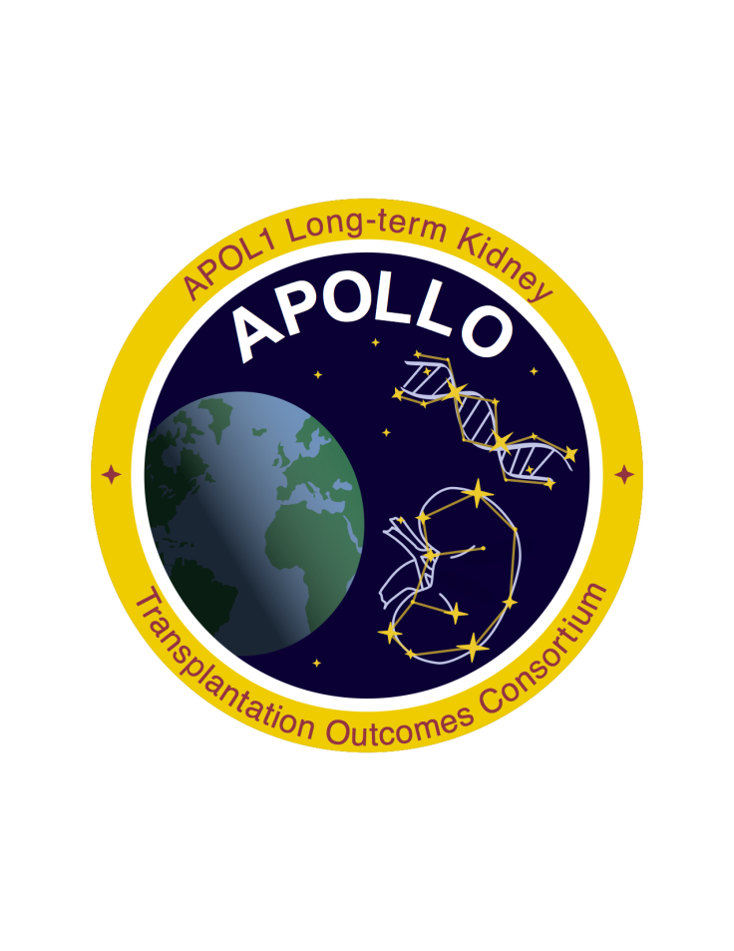

After transplantation of this kidney, please contact:
- the designated APOLLO study coordinator at your Clinical Center, OR

- the research staff at your transplant center, OR

- if you need assistance identifying the correct staff to contact, email the APOLLO Coordinating Center staff – APOLLOstudy@wakehealth.edu

For more information about the APOLLO research study, visit our website:
Website: www.TheApolloNetwork.org

Thank you from the NIH APOLLO Consortium!

Appendix 3 APOLLO Inventory and Shipping Spreadsheet

HLA Lab ID: |  | Ship Date:
 |  |  | Person Fedexing:

Appendix 4 Template Language to be Included with Donor Family Follow-up:

“In addition to the organs noted above that were recovered and transplanted, small samples of blood and urine were recovered and are a part of the APOLLO research project being performed by the National Institutes of Health (NIH). The goal of this research project is to determine whether alterations in a gene (called the apolipoprotein L1 gene or APOL1), sometimes found in kidney donors and/or recipients with African ancestry, will impact kidney transplantation outcomes.

Once blood samples have been collected from all kidney donors in the study, during an approximate 2 - 3 year study period, it may be possible for you to find out the results of the gene test for your loved one. We will write to provide you additional information about how you can get access to this information once it becomes available in the later years of the APOLLO study.”

